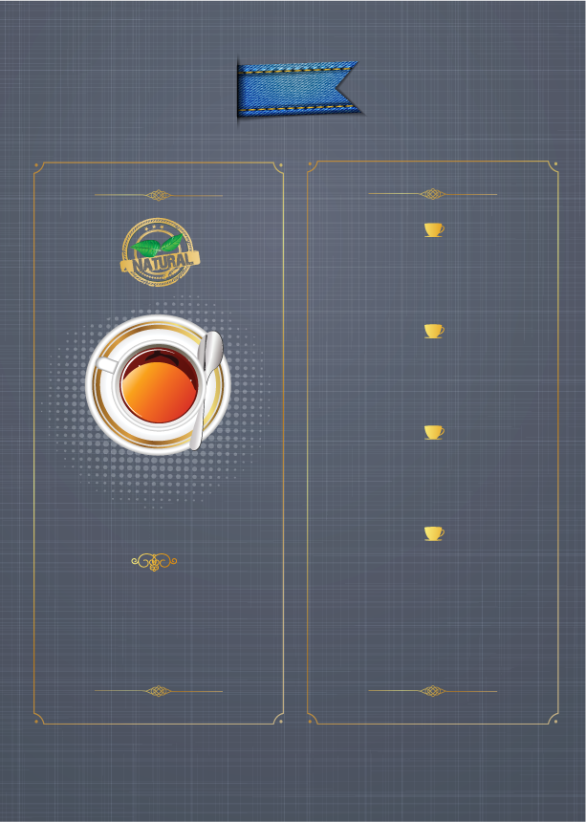
菜單

訂位專線：(02) 2522-3900
咖啡A
XXXXXXXXXXXXXXXXXX
$100
咖啡B
XXXXXXXXXXXXXXXXXX
$100
咖啡C
XXXXXXXXXXXXXXXXXX
$100
咖啡D
XXXXXXXXXXXXXXXXXX
$100

